APPENDIX A
PHOTOGRAPHS TAKEN DURING JIV AT 16” TUNU-BRASS CREEK DELIVERY LINE AT AGBIDIAMA COMMUNITY, EKEREMOR L.G.A, BAYELSA STATE.
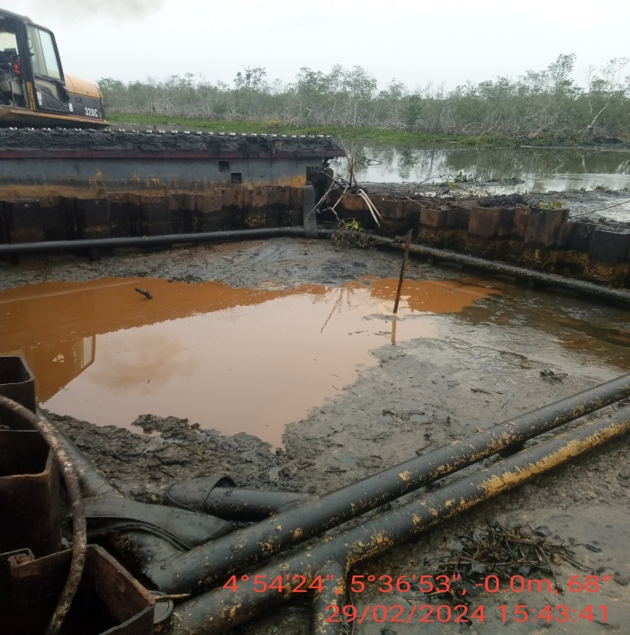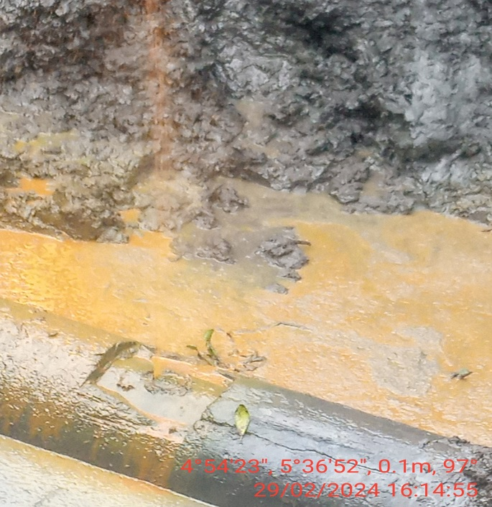
Fig. 1: Incident point on arrival at the site. Fig. 2: Straight cut at 12 O’ clock position.
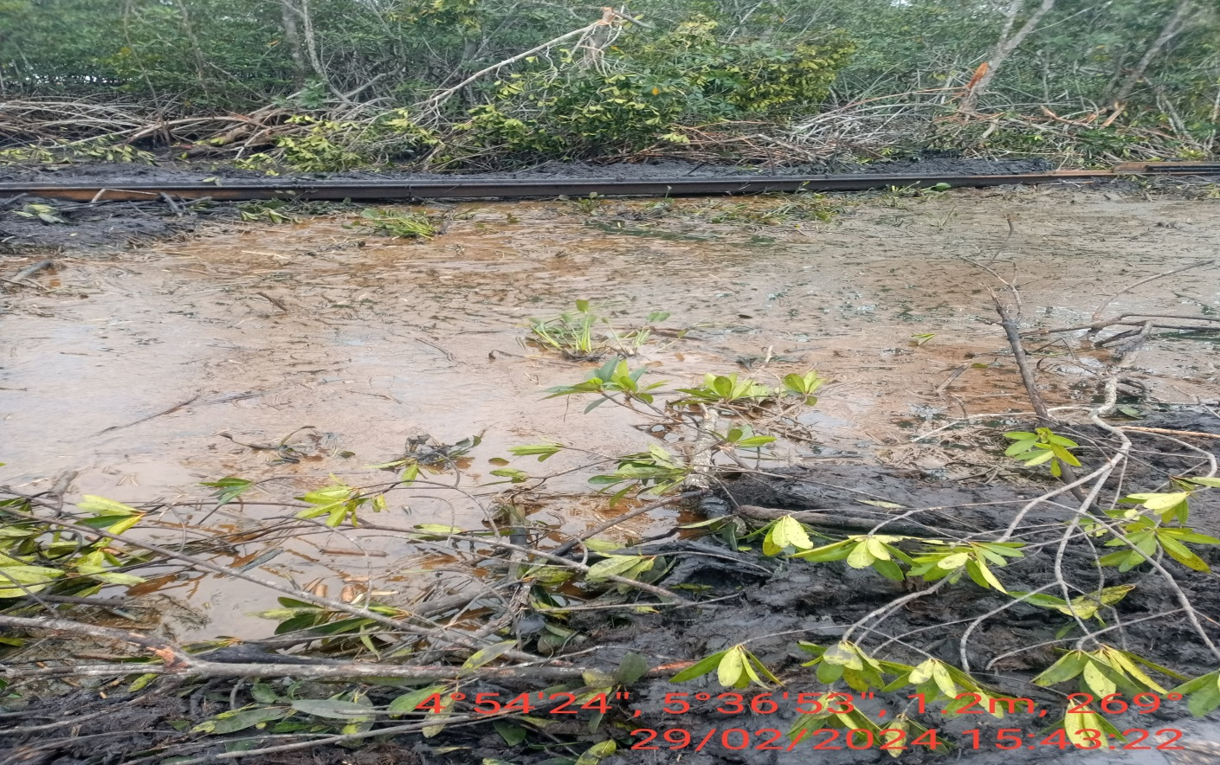
Fig. 3: Pit containing spilled oil from the incident point

